Submitted by:   
Abdullah Al Noman   
Id: 242832  
Year 1st, Term 2ndLaw Discipline

Course Name: Principles of Sociology

Course Code: 0314 28 Soc 1253

Society is the Web of Social Relationships.

An Assignment on



# Table of Contents

Table of Contents 1

1. Introduction 2

2. Social Relationship 3

3. The "Web" Metaphor 5

4. Society 7

5. Conclusion 8

# 1. Introduction

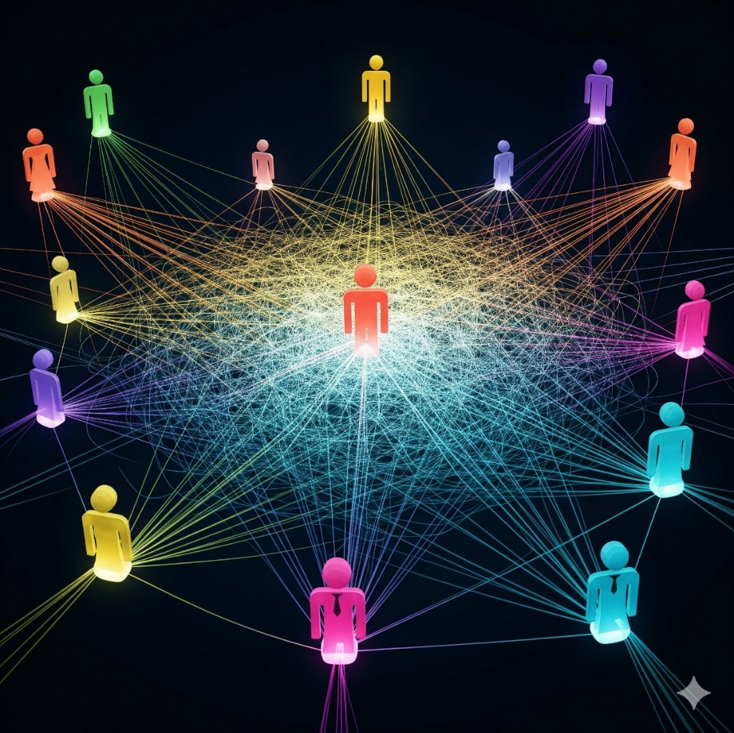Society is a term that we use in our daily life to generally indicating a group of people living together. But is it just a group of people living together, or it is a physical place, or is it a kind of institution or is it simply a collection of people? For centuries, many thinkers have asked these kinds of questions and answer them differently. Among them, one renowned sociologist named **MacIver** famously stated that, "**Society is the web of social relationships.**" This single statement shifts focus of sociologists from considering society a collection of people to its complex network of connections, interactions and relationships that exists between people. His statement shows the underlying connections and interactions that has actually created a society. A group of isolated people can't be called society. This assignment will explore and try to understand what is **social relationship**, what is actually mean by the metaphor "**web**" and lastly, we will explore what **society** actually is.

Figure 1: The web of relationships

# 2. Social Relationship

Social relationship is more than just simple interaction like nodding or greeting a stranger or saying 'hello' casually. It is more than those simple interaction. Social relationship is the connection among individuals on their mutual awareness and interaction. It is not any kind of physical objects but it is an abstract idea on how people would react and behave with each other. Social relationship has a history and a future too. Based on the previous interaction, people create different types of social relationship. So, in simple term, social relationship are the bond and connections between individuals. This kind of relationship can be formal like the relationship between student and teacher or the relationship between the employer and employee. In formal relationship, all work together to achieve the same goal. They don’t have that much intimate relationship like between family members and friends.

Relationship between family member and close friends or childhood playmates are primary relationships which are close, personal and long-lasting. They are created through many recurring interactions. These are the relationships that needed face to face interaction and a high degree of emotional intimacy. They have strong impact on each other.

Figure 2: Primary relationships (Close Friends)

On the other hand, the relationship between student and teacher, judge and lawyer, doctor and patient are formal relationships as they are secondary relationships. Those secondary relationships are impersonal and goal oriented. They don't have that much intimacy and individuals are seen in terms of their roles. These kinds of relationship are temporary, goal oriented, impersonal and formal.



Figure 3: Secondary relationships

# 3. The "Web" Metaphor

The metaphor "web" has a profound meaning. The spider's web serves as a powerful analogy for society. It can profoundly represent the underlying relationships of society.

The threads of spider's web are interconnected and each thread depends on each other. Just like that social relationship are interconnected and dependent on each other. They are not isolated. Like just as a disturbance in any part of web would disrupt and send vibration to the whole web, a person's relationship with their employer directly impacts their relationships within their family, their economic status and their friendship. And if someone loses their job, it doesn't just change the relationships of the job but it effects all other aspects of him like family, friends, social status etc. So, it is like, they all are connected through invisible threads of web. They all are interconnected and not isolated events.

Figure 4: Interconnectedness like web

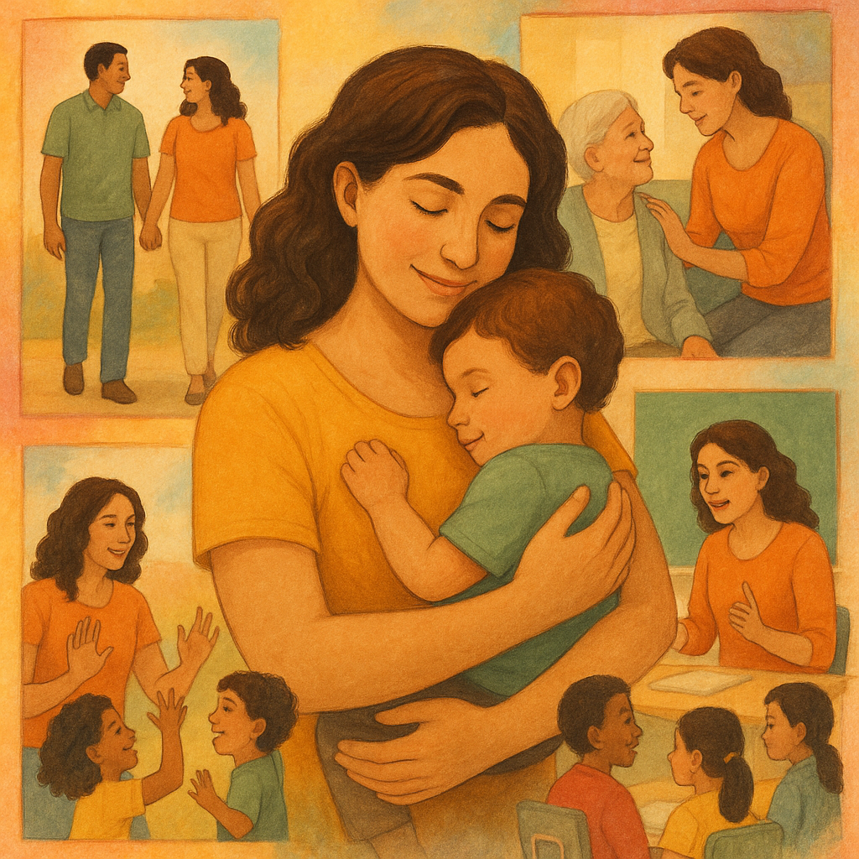The threads of web aren't just random tangles of threads but a clear structured, complex pattern. Just like that, Society is composed of clear structured and complex patter and behavior. In society, on one behaves randomly. They have a role and they try to fulfill the role. And even more an individual doesn't just have one role, they have to play many different roles simultaneously like A woman isn't just a woman, she has to play the role of a mother, a wife, a daughter, an aunty, a teacher and many more. So, the relationships are really complex but it has a clear pattern and interconnectedness.

Figure 4: A woman playing many complex but structured interconnected roles in society.

# 4. Society

A society isn't any physical thing. Society is fundamentally abstract and we can't see or touch them physically. It is actually a web of social relationship. All the things that we see are people and their results of their social relationships like the beautiful building, the road, the street, the territory, the arts etc. We can't see the underlying web itself.

Actually, society exists in the shared understanding of people, their mutual expectations, and the patterned of behavior that flows between individuals. It is not in a static state, it is continuously changing through daily interactions

The relationships are not random in society at all. They have a proper structure and pattern. Like society is regulated by social norms, customs, traditions and laws. Like a relationship between a teacher and a student governed by expectations of respect, authority and the pursuit of knowledge.

The threads of social relationships in society aren't always positive. While relationships are often based on cooperation, love, and mutual aid, they also encompass conflict, competition, and rivalry. Both forces are essential aspects of social life. Those opposing forces often influence social change.

# 5. Conclusion

# Society is built on the social relationships which is like a web. The web is invisible but we can feel and understand the web through our interaction with each other. Our social relationships aren't just a normal fleeing nodding or greeting, they are complex but interconnected and have a behavioral pattern. It also a history of interaction upon which our social relationships are build and also has a future expectation. Everyone has multiple, sometimes overlapping roles in the society to play. And all those relationships are complex, interconnected but patterned like a spider web.

So, society is abstract and we can't see it but we can understand the underlying relationships, connections and forces of society and we can see the people in a society and their creation like buildings, roads and arts. So, the definition of society, "Society is the Web of Social Relationships" given my R.M. MacIver, is a cornerstone of modern sociology because of its profound simplicity and accuracy. This perspective, championed by MacIver, reveals the true substance of social life: the invisible, yet powerful, network of connections that binds us together. It highlights that we are all nodes in a vast, interconnected system, shaped by the relationships we inherit, create, and maintain. Our individual identities, behaviors, and life chances are profoundly influenced by our position within this intricate web. Therefore, to study society is to study the patterns, nature, and dynamics of these relationships, for they are the very fabric from which our social world is woven.